

WWWWWWWWWWWWWWWWWWWWWWWWWWWW
ZPHS ARAI ARAI

WWWWWWWWWWWWWWWWWWWWWWWWWWWW

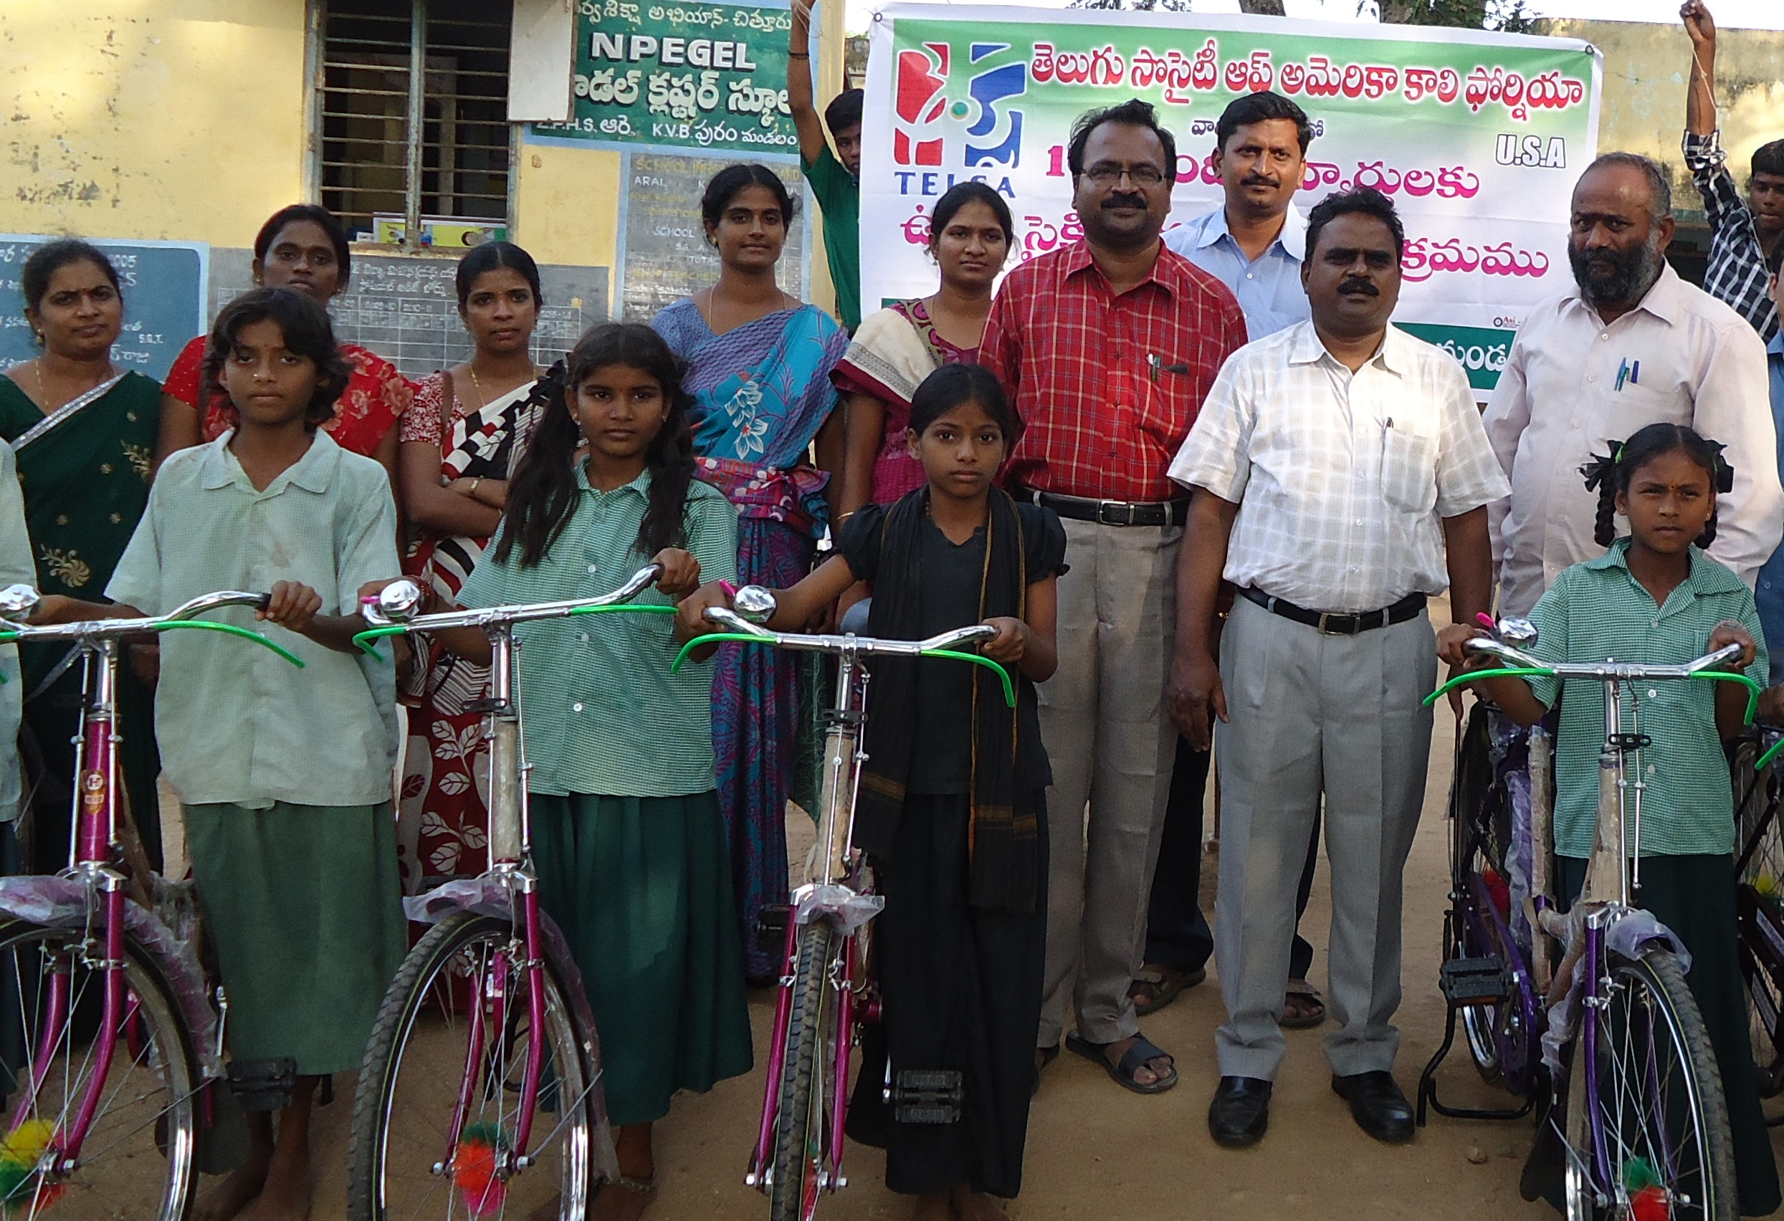

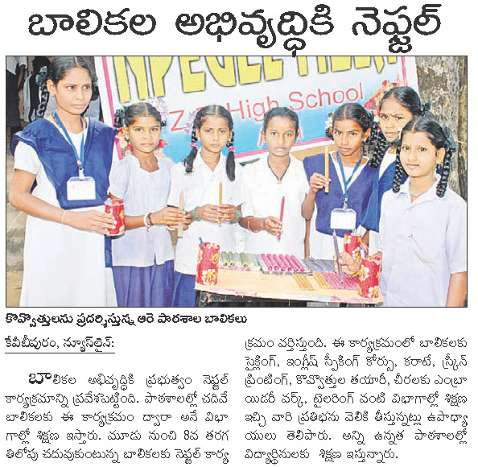

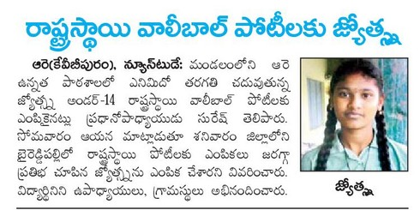

2

SCHOOL PARTICULARS

Name of the School : ZPP High School
Address : ARAI
Dise Code of the School : 1023608
Panchayat : ARAI
Mandal : K.V.B PURAM
Division : PUTTUR
District : CHITTOOR
Assembly Constituency : SATHYAVEDU
Parliamentary Constituency : TIRUPATI
Name of the Headmistress : Sri G.SURESH
Name of the MEO : Sri H.UGANDRA RAJU
Name of the Dy.E.O : Sri Dr V.SEKHAR
Name of the D.E.O : Sri T.PRATHAP REDDY
Contact No. of the School (if any) :
(With STD Code)

Contact No. of the H.M : 9573265620
E-mail ID of the School : headmasterarai@gmail.com
Bank/P.O.A/c No. of the School : 30985875300
RMSA Bank A/c.No : 30986019846
SMC Bank A/C, No ; 30438962923

3

INDEX

CHAPTER  NO | TITLE | PAGE NO
1 | VILLAGE PROFILE-GEOGRAPHIC | 4
2 | VILLAGE PROFEILE-DEMOGRAPHIC | 5
3 | SCHOOL PROFILE | 6
4 | NEEDS/GAPS IDENTIFIED FOR IMPROVEMENT | 8
5 | STRATEGIES & INTERVENTIONS | 10
6 | EDUCATION FOR SC/ST/MINORITY/GIRLS | 12
7 | National Programme for Education of Girls at Elementary  Education (NPEGEL | 13
8 | INNOVATION | 14
9 | COMMUNITY MOBILISATION | 15
10 | OTHER INTERVENTIONS & SPECIFIC PROPOSAL | 16

4

CHAPTER – I
VILLAGE PROFILE –GEOGAPHIC

The ARAI is a major Panchayat with 4 wards. It is a village of K.V.B PURAM Mandal .Which is chittoor Diatrict Middikandriga, Kunnamkalathur, Sreenivasapuram, Sadhasivapuram, Kotamangapuram and D puttoor are the neighboring villages.

The Longitude is : 13.3155 N
The Latitude is : 79.4419 E

The village is at the distance of 5 Km from the Mandal Headquarters and 90 Km from the District Headquarters. The village is connected by Road and the Nearest Railway Station is about in 25 Km i.e., Puttoor with a distance of 900 Km from the State Headquarters.

The main activity in the village is Cultivation. The lands are fertile and there is irrigation system for agricultural development. Paddy, Sugarcane, Grand nuts are the major crops. The farmers are educated enough to know the latest trends and developments in their fields. Frequent transportation is available by means of Auto’s. The ground water is suitable for drinking purposes. Drinking water distribution system is in village maintained by the local Panchayat.

Bay of Bengal is only 3 Km from this village and the nearby village is Uppada, which is famous for its handlooms. The sea is very aggressive with high tides causing so much of erosion to the roads and penetrating into the village. The evening sunset at this sea shore is a pleasure moment for nature lovers.
5
CHAPTER – II
VILLAGE PROFILE – DEMOGRAPHIC

The total population of the village is 1451 with 730 (49.5%) Males, 8.8% S.C, 39.4% OBC and balance of ST and other Minorities.

Wards | ST |  |  | SC |  |  | OBC |  |  | OC |  |  | Total
Wards | M | F | T | M | F | T | M | F | T | M | F | T | M | F | T
3 | 50 | 41 | 91 | 166 | 182 | 348 | 321 | 327 | 648 | 193 | 171 | 364 | 730 | 721 | 1451

Source: Census 2011

The 14+ and 15+ age group population is 202 and 201 respectively with 221 boys and 182 girls indicating the gender disparity of 8.23%.
 | Boys | Girls | Total
14+ (Boys & Girls) | 8 | 7 | 15
15+ (Boys & Girls) | 2 | 3 | 5

LITERACY

Village Literacy Rate : 74.00%
Mandal Literacy Rate : 56.91%
District Literacy Rate : 67.46%
State Literacy Rate : 61.50%
National Literacy Rate : 65.20%

The village literacy rate is 74% which is above the Mandal average of 56.91% and the district average of 67.46% and state of 61.5%.and also the National literacy rate. The village Literacy Rate is to be improved at least at par with the National Literacy Rate. Though the village has more no. of teachers, the village is behind the District, State and National averages.
6

CHAPTER – III
SCHOOL PROFILE

The School is about 6 Km from the Mandal Headquarters. It is under the management of Zilla Parishad The school imparts education for the classes VI to X, with single section for each class, in both Telugu and English Medium of State Syllabus and is not using the school building as a shift-school.
The School building is a pucca building with RCC roof housed in a government building. Only 8 class rooms are available for teaching 10 classes. The school has no Toilet facility state due to lack of running water. The school NO drink water facility. Its Boundary wall is partial and needs to be completed. The school has not sufficient furniture for the students And for the Staff members Laboratory room is not available The school has wide range of nearly 1000 books but it has no Library Room
.
The school has 11 teaching staff under permanent establishment. The school requires a teacher for Physical Sciences. Out of11 teaching staff 3 are OC, 4 are BC, 2 are SC . All the teachers have the good qualifications and all are professionally trained. Some of them are Graduates and some are Post Graduates and among them is Ph.D holder. The School has the Physical Education Teacher for the benefit of children. There are 2 vidhya volunteers’ in the school.

HM | SA | LP | PET
1 | 8 | 1 | 1

The school has the enrolment is increasing year by year as it is 106 in the year 2007-08, 130 in the year 2008-09, 130 in the year 2009-10 and 131 and it is 141.in the current year 2010-11

7

YEAR | SC | ST | BC | OC | Total
2007-08 | 23 | 04 | 69 | 10 | 106
2008-09 | 32 | 05 | 80 | 13 | 130
2009-10 | 27 | 05 | 94 | 05 | 131
2010-11 | 26 | 04 | 108 | 03 | 141
2011-12
2012-13

The School has School Management Development Committee (SMDC) with Headmistress as the Chairman,

Chairman - 1
Faculty Members - 4
Parent Members - 2
Grampachnyayat Members - 2
Ednl. Develop. Committee Member - 1
Mandal Educational Officer - 1

School Building Committee & Academic Committee is its subsidiaries.

All the students studying in the school have the aim to reach the highest position in every aspect in Academic as well as other activities.

8

CHAPTER – IV

NEEDS/GAPS IDENTIFIED FOR IMPROVEMENT

The school is achieving good results in academics but not up to the mark in the physical infrastructure like Toilet Blocks, Class rooms, Laboratories etc. The villages like Kunnamkalathur, and D puttoor have no conveyance facilities. Access is one of main reason for dropout rate in the admissions. Though the school topper is with 473/600 marks and 69% pass percentage, parents are joining their children in other private schools only for their crazy reasons. If the above said infrastructure is provided they may turn towards our school.

The school is in the jurisdiction of the Puttur Education Division though it is physically in the Chittoor Revenue division . The village comes under Sathyvedu Assembly Constituency and Tirupati Parliamentary Constituency.

As the school has no Toilet Block, it became useless for wanting of running water facility. There is no drinking water facility in the school. Conveyance facilities are to be improved.

Mrs.G,SURESH is the Headmster of the school. All the teachers in the school are professionally trained and they are getting training at regular intervals to update themselves with the recent updates in the subject as well as in methodology and in improving their professional efficiency.

The school needs fund for meeting the Major repair of avoiding leakage from the roof. Though the building constructed in 2009 the roof is leaking in rainy. villagers realized that the school is better than many and the staff are working their best to make it best.

To reduce the dropout rate in all classes, campaigning the importance of education and about the school through BADIBATA PROGRAMME.

9

Increasing the learning resources through community mobilization and by organizing the lectures/seminars by subject and professional experts will bring lot of change in developing the awareness of the present day situation and in promotion of holistic development of children in all walks of life. Subject Clubs, Laboratories will increase the learning resource and enrich the academic concepts.

Every year week long adolescent education programme is being organized duly utilizing the services of the specially trained teacher in that area so that the children who are in the adolescent age can get guidance to understand the physical, psychological, physiological changes and controlling their emotions. Before the examinations, to motivate and to increase the confidence levels the interaction with eminent psychologists are being invited

For bridging up the above said gaps approximately an amount of Rs.30 Lakhs is required for construction of classrooms and for providing other basic amenities The problem of conveyance may be solved by issuing loans to the unemployed of the remote villages to purchase Auto Rikshaw’s.

PREPARATION OF TOOLS FOR CONTINUOUS AND COMPREHENSIVE
EVALUATION
Base Line Test, Monthly Unit Test, Mid-term Examinations, and Assignments, are conducted with the help of the DCEB and the Teachers. Question-wise analysis is also made to know the learning levels of the students.
Budget provision may be made for implementing the above said innovations and Rs.2,000/- are required.

10

CHAPTER – V
STRATEGIES AND INTERVENTIONS

There is no quantitative expansion for a new school. The existing schools may be strengthened for imparting quality education. The schools need at least three more class rooms immediately. There are no other rooms in the school and they may be prioritized after fulfilling the classrooms.
. There is lot of potential for enrolment of class IX if conveyance facility from the feeder villages is improved. Some parents are joining their children for want of English Medium. The so called Corporate schools are offering some incentives (waiving off fee etc.) and grabbing the meritorious students into their schools. If the government facilitates the same they stay here only.
Strategies to bring back class VIII graduates who dropped out are implemented in the catchment area. Campaigning about the school in the Gram Panchaiath, explaining the positive strengths of the school like abilities and qualifications of the teachers working in the school are giving fruitful results.
I herewith propose the budget for the above said activities as Rs.50,000/-
By providing quality infrastructure and learning resources, the school can be developed. Guest Lectures, Seminars, Workshops on the subject content can improve the learning skills among children. As the village is neither interior nor hilly terrain, providing of residential accommodation for female teachers may be utilized for other needy places. The teachers are paying maximum efforts for the holistic development of the children through promotion of sports, cultural activities, exposure to life skills with regard to health, nutrition and personality development.
The school invites agricultural officers, Horticultural officers, Forest Range Officers, artisans and other professionals to create awareness among the students about vocational, professional education and ecological system. There is no trained teacher in Centre for Cultural Research & Training(CCRT) for which application was sent to impart training for at least one teacher and provide cultural kit

11
.
The school has subject clubs headed by the concerned subject teachers and they conduct the literary activities, quiz competitions and preparing project works. The school participated in the Science Fairs’ which were organized at different levels. The school has handful of books and one teacher is holding the responsibility of librarian also apart from his/her academic duties. The non language teachers are adjusting their time table so that every week at least one period can have learning while doing in the labs. The School observes week long adolescent education programs, every year so that they can understand the mental, physical, physiological changes occur at this age. The government is providing, special training, material and financial liabilities for this purpose. Two teachers are working as counselors for Guidance in both academic and non academic matters.

The SMDC has met 5 times in this academic year and discussed for the development of the school and children. Immediately after the completion of either Unit Tests or Terminals, the PTA meeting will be called for to discuss the achievement, answer scripts will be shown to the parents to know the performance of their children. Progress Report will be issued after every examination.

The Pupil-Teacher Ratio is 1:25 which is good and no teacher was deputed in the last academic year on Non-academic works. No teacher was irregular and No one is on Leave on Loss of Pay (LLP).

The average attendance of the school in last year is in between 85% and 95%. If the conveyance facilities are improved it can be improved. The school observes all the days of importance and celebrates all the festivals of the National Interest. Proposed Budget for implementing above strategies the school requires Rs.2000/-.

12
CHAPTER – VI
EDUCATION FOR SC/ST/MINORITY COMMUNITY & GIRLS
As the SC, ST and Minorities are good at enrolment and success rate. Member for SC, ST in the SMDC will hold the responsibility for the above strategies. As this result they are stepping ahead with good scores.
QUALITY
The grant for the TLM (`3000) was utilized for the purpose for which it is meant. The slow learners will be taken care of by imparting remedial coaching and micro teaching. The school also conducts “BADI BATA” program at the starting of the academic year to reduce drop-out rate.

The students have the facility to know what the opportunities for their career and future. They have guide teacher to explain all these things. There is No Girl’s hostel in the village. Yet there is girils spl school (KASURIBHA SCHOOL) In the mandal headquarters for girils droupouts.
.
As the local people are interested in education, with the help of them the school announces prizes, awards and incentives, even financial assistance for the poor students. The school also awards the children with good attendance to improve the average attendance. The absenteeism of the student will be informed through messaging, teacher visits to their houses, keeping in notice of SMDC..

SPECIAL COACHING CLASSES:
Special Coaching classes for the slow learners, especially for SSC students are being conducted. The school conducts classes for them even in term holidays and Sundays also. Vijayosthu programmes are being held at mandal level duly orienting them about the trends & techniques to get above A GRADE.
.

13

National Programme for Education of Girls at Elementary
Education (NPEGEL)

The National Programme for Education of Girls at Elementary Level (NPEGEL), is a focussed intervention of Government of India, to reach the “Hardest to Reach” girls, especially those not in school. Launched in July 2003, it is an important component of SSA, which provides additional support for enhancing girl’s education over and above the investments for girl’s education through normal SSA interventions. The programme provides for development of a “model school” in ARAI cluster with more intense community mobilization and supervision of girls enrolment in schools. Gender sensitisation of teachers, development of gender-sensitive learning materials, and provision of need-based incentives like escorts, stationery, workbooks and uniforms are some of the endeavours under the programme.

The scheme is being implemented in educationally backward blocks (EBBs) where the level of rural female literacy is less than the national average and the gender gap is above the national average; in blocks of districts which are not covered under EBBs but are having at least 5% SC/ST population and where SC/ST female literacy is below 10%; and also in select urban slums

The Community awareness programs on education girl child are taken up for the above said strategy. Ensuring Safety and Security of girl child while commuting the school is most important, both villagers and teachers have very strict disciplinary attitude towards the eve teasers and anti social elements. Provision of transport to the girl child is the major problem. The Bi-cycles are to be provided for the girls who are coming from distant and remote villages.

14

CHAPTER – VII
INNOVATION

Once every one month, a health check up camp is to be organized in the school by the PHC. Eye Camps for the children are conducted by service organizations.
.
Guidance Counseling Centers are to be established by professional for the sake of students. At least at Mandal Level one Teacher who is specialized in Guidance & Counseling may be appointed and he may be expected to visit all the high schools in that mandal every month on rotation basis.
As the school ground is adopted by the local Forestry Dept., the students are given work experience training by the experts of the Horticulture Dept., to care the greenery and planting techniques at their homes. The agricultural kits may be supplied to the school.
.
TRAINING OF GIRILS IN LIFE SKILLS & CAREER GUIDANCE
- Training the Girils life skills is done by the guest lectures by the
experts in different fields

. 2. By training them in vocational skills like painting,tailoring,
candels making,spiral binding,chack making.greetingcards
preparation,

3. Requesting the diet lectures to come and train the students in this
concerned.

4. The village has 2 teachers, 2 Policemen, and several no. of other professionals who have a bright vision towards the future of their children and the school gets benefit out of it.

15
CHAPTER – VIII
COMMUNITY MOBILISATION

The parents of the students who are attending in other schools will be met and convinced to join their children in our school duly explaining the conditions and abilities of the school and teachers, results achieved, positions held by our students in different examinations and strengths of the school.

The teachers in the government schools are more qualified and experienced than those are working in the private schools. The school has secured high position in the district as well as in imparting the quality education. Special classes for the slow learners will be arranged. There is no necessity for the private tuitions etc. These points are to be inculcated in the minds of the parents.

The students selected for IIIT from the school and old students employed in different sectors residing in the village are together guiding the present batches in career options and future studies.

In this aspect the PTA is also to be trained in the areas of how deal the adolescent children and take care about their future. The training is to be given by the local leaders, youth etc.

The attitude of some sector of people, who feel that sending their children to Government school is inferior to their prestige is to be changed.

The proposed budget is Rs.2,000/-.
16

CHAPTER – IX
SUGGESTED INTERVENTIONS AND SPECIAL PROPOSALS
1. To impart intensive in-service training to the teacher to elevate their
teaching capabilities.
2. To make the child to undergo regular health checkup, and give
necessary medical assistance.
3. Along with the Mid-day Meals the child has to be given a glass of Milk.
4. The Vitamins for Calcium, Iron, and Vitamin -A, have to be supplemented for the High School children especially for girls.
5. To provide equipped Laboratory and furnished Library along with
Librarian.
6. To provide proper conveyance for the students coming from the
surrounding villages.
7. Bicycles are to be given for the children coming from the distant native villages.
8. Urinals & Toilets with running water facility are to be provided as they are very important for girls.
9. Hostel facility for the girls coming from the interior places.
10. Complete Games and Sports equipment are to be supplied for the all round development of the child
Proposed budget for the above strategies :- Rs. 3,00,000/-

HEADMASTER
ZPP HIGH SCHOOL ARAI,
K.V.B PURAM (M)

